Задание выполнялось на компьютере со следующими параметрами:

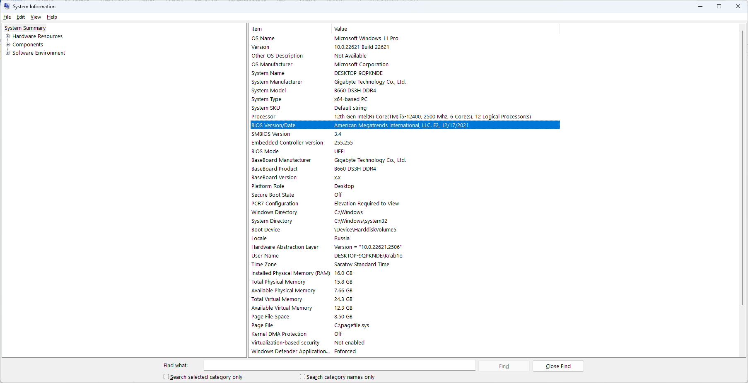

Из важного:

CPU: 12th Gen Intel(R) Core(TM) i5-12400, 2500 Mhz, 6 Core(s), 12 Logical Processor(s)

Motherboard: B660 DS3H DDR4

RAM: 16.0 GB со скоростью 2400MHz

Вариант 3. Реализовать метод верхней релаксации:

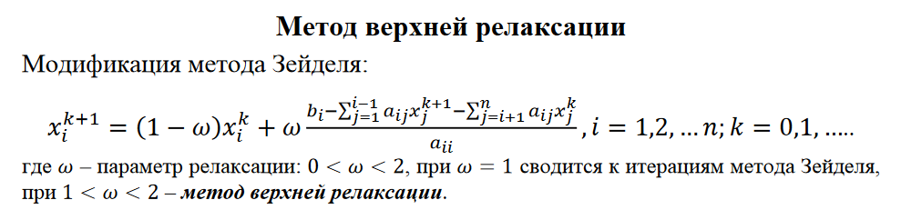

|  |  |  |  |
| --- | --- | --- | --- |
| Номер теста | Порядок системы | Ускорение алгоритма Гаусса | Ускорение итерационного алгоритма (верхн. релакс) |
| 1 | 10 | — | — |
| 2 | 100 | 0.5 | 0.5 |
| 3 | 500 | 2.342 | 1.31 |
| 4 | 1000 | 3.816 | 1.68 |
| 5 | 1500 | 4.425 | 2.05 |
| 6 | 2000 | 4.530 | 2.67 |
| 7 | 2500 | 4.368 | 3.56 |
| 8 | 3000 | 4.24 | 4.01 |

Код:

#define _CRT_SECURE_NO_WARNINGS

#include <stdio.h>

#include <stdlib.h>

#include <conio.h>

#include <time.h>

#include <math.h>

#include <omp.h>

const double eps = 0.000000001;

const double relaxParam = 1;

int* pPivotPos; // The number of pivot rows selected at the iterations

int* pPivotIter; // The iterations, at which the rows were pivots

// Function for simple initialization of the matrix

// and the vector elements

void DummyDataInitialization(long double* pMatrix, long double* pVector, int

Size) {

int i, j; // Loop variables

for (i = 0; i < Size; i++) {

pVector[i] = i + 1;

for (j = 0; j < Size; j++) {

if (j <= i)

pMatrix[i * Size + j] = 1;

else

pMatrix[i * Size + j] = 0;

}

}

}

// Function for random initialization of the matrix

// and the vector elements

void RandomDataInitialization(long double* pMatrix, long double* pVector, int Size) {

long double s;

int i, j; // Loop variables

srand(unsigned(clock()));

for (i = 0; i < Size; i++) {

pVector[i] = rand() / double(1000);

for (j = 0; j < Size; j++) {

pMatrix[i * Size + j] = rand() / double(1000);

}

}

for (i = 0; i < Size; i++) {

s = 0;

pVector[i] = rand() / double(1000);

for (j = 0; j < Size; j++) {

if (i != j)

s += pMatrix[i * Size + j];

}

pMatrix[i * Size + i] = rand() / double(1000) + s;

}

}

// Function for memory allocation and definition of the objects elements

void ProcessInitialization(long double*& pMatrix, long double*

& pVector, long double*& pResult, int& Size) {

// Setting the size of the matrix and the vector

do {

printf("\nEnter size of the matrix and the vector: ");

scanf("%d", &Size);

printf("\nChosen size = %d \n", Size);

if (Size <= 0)

printf("\nSize of objects must be greater than 0!\n");

} while (Size <= 0);

// Memory allocation

pMatrix = new long double[Size * Size];

pVector = new long double[Size];

pResult = new long double[Size];

// Initialization of the matrix and the vector elements

RandomDataInitialization(pMatrix, pVector, Size);

//DummyDataInitialization(pMatrix, pVector, Size);

}

// Function for formatted matrix output

void PrintMatrix(double* pMatrix, int RowCount, int ColCount) {

int i, j; // Loop variables

for (i = 0; i < RowCount; i++) {

for (j = 0; j < ColCount; j++)

printf("%7.4f ", pMatrix[i * RowCount + j]);

printf("\n");

}

}

// Function for formatted vector output

void PrintVector(long double* pVector, int Size) {

int i;

for (i = 0; i < Size; i++)

printf("%7.4f ", pVector[i]);

}

// Function for the execution of Gauss algorithm

void ParallelResultCalculation(long double* pMatrix, long double* pVector,

long double* prevResult, int Size) {

long double* curResult = new long double[Size];

#pragma omp parallel for

for (int i = 0; i < Size; i++)

{

prevResult[i] = 0;

curResult[i] = 0;

}

bool flag = false;

long double sum;

do {

flag = false;

for (int i = 0; i < Size; i++) {

curResult[i] = pVector[i];

sum = 0;

#pragma omp parallel for reduction(+: sum)

for (int j = 0; j < Size; j++) {

if (i != j)

sum += pMatrix[Size * i + j] * curResult[j];

}

curResult[i] -= sum;

curResult[i] = (1 - relaxParam) * prevResult[i] + relaxParam * curResult[i] / pMatrix[Size * i + i];

//curResult[i] = curResult[i] / pMatrix[Size * i + i];

//Check if difference between current computations and previous ones exceed eps

if (fabs(curResult[i] - prevResult[i]) >= eps)

flag = true;

prevResult[i] = curResult[i];

}

} while (flag);

delete[] curResult;

}

// Function for computational process termination

void ProcessTermination(long double* pMatrix, long double* pVector, long double* pResult) {

delete[] pMatrix;

delete[] pVector;

delete[] pResult;

}

// Function for testing the result

void TestResult(long double* pMatrix, long double* pVector,

long double* pResult, int Size) {

/* Buffer for storing the vector, that is a result of multiplication

of the linear system matrix by the vector of unknowns */

long double* pRightPartVector;

// Flag, that shows wheather the right parts

// vectors are identical or not

int equal = 0;

long double Accuracy = 0.001; // Comparison accuracy

pRightPartVector = new long double[Size];

for (int i = 0; i < Size; i++) {

pRightPartVector[i] = 0;

for (int j = 0; j < Size; j++) {

pRightPartVector[i] +=

pMatrix[i * Size + j] * pResult[j];

}

}

for (int i = 0; i < Size; i++) {

if (fabs(pRightPartVector[i] - pVector[i]) > Accuracy)

equal = 1;

}

if (equal == 1)

printf("The result of the parallel Gauss algorithm is NOT correct."

"Check your code.");

else

printf("The result of the parallel Gauss algorithm is correct.");

delete[] pRightPartVector;

}

int main() {

long double* pMatrix; // The matrix of the linear system

long double* pVector; // The right parts of the linear system

long double* pResult; // The result vector

int Size; // The sizes of the initial matrix and the vector

long double start, finish, duration;

printf("Serial Gauss algorithm for solving linear systems\n");

// Memory allocation and definition of objects' elements

ProcessInitialization(pMatrix, pVector, pResult, Size);

// The matrix and the vector output

printf("Initial Matrix \n");

//PrintMatrix(pMatrix, Size, Size);

printf("Initial Vector \n");

//PrintVector(pVector, Size);

// Execution of Gauss algorithm

start = clock();

ParallelResultCalculation(pMatrix, pVector, pResult, Size);

finish = clock();

duration = (finish - start) / CLOCKS_PER_SEC;

TestResult(pMatrix, pVector, pResult, Size);

//Printing the result vector

printf("\n Result Vector: \n");

PrintVector(pResult, Size);

// Printing the execution time of Gauss method

printf("\n Time of execution: %f\n", duration);

// Computational process termination

ProcessTermination(pMatrix, pVector, pResult);

return 0;

}